**Terrain Editing via touch**

Last Updated: November 23rd 2012

# High Level Player Experience

Create and manipulate the terrain in Kodu via a touch screen interface.

**Feature Priority:**

*Key Feature*: This is the one feature that the game essentially is wrapped around. It extends into every part of the game, and each part directs back into it.

# Design Details

**Goals:**

* To enable Users to create wonderful terrains, with maximum possibilities and minimum frustration.
* To make best use of the touch screen interface.

**Breakdown**:

* Introduction
* Terrain Interface
* Terrain
* Ground brush, water tool, delete tool

**Introduction**

Creating terrain and editing it is an important aspect of level creation. With touch control, we are the closest we can be to the User being able to manipulate the world using motions they already know.

The ground brush (painting materials on terrain), water tool and delete tools are included after the initial section on terrain creation and modification.

Note: The camera controls for Terrain mode are no different to in any other mode.

**Terrain Interface**

The terrain tools in the current version of Kodu remain, only how they are accessed changes. The Edit menu doesn’t change in its primary functionality, the same tools add, flatten, water, etc don’t change from the Mouse or Controller input.

As covered in Kodu with Touch, appearance wise, the Edit menu looks flat like the Mouse version, but uses the square tile buttons from the Controller version and includes a dead space immediately behind it so a miss-tap doesn’t action something the player didn’t intend.

The only change to the edit menu terrain buttons are the material and brush selector additional buttons which move to our sidebar buttons.

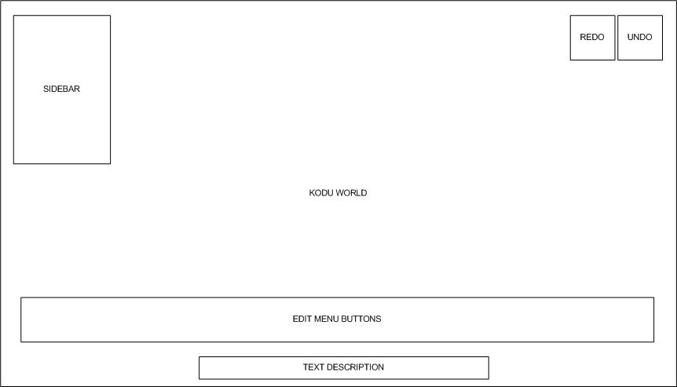

**Terrain creation and modification**

**Terrain Edit mode**

The terrain tool mode takes advantage of new GUI buttons in a “Sidebar”. Exact layout TBC.

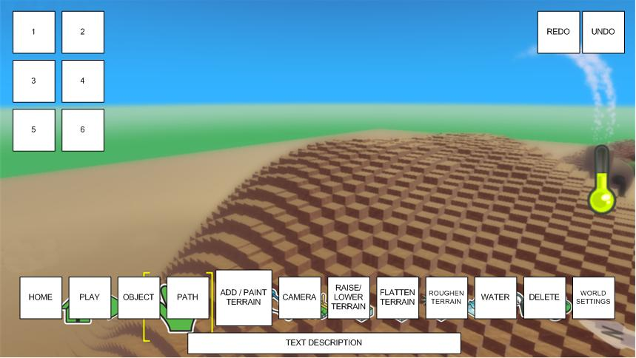

*Note repositioning of the Camera entry. This is to speed terrain editing. Final positions of all buttons TBD.*

Many of the terrain editing tools are modes that the User taps on and taps off (no press and hold required). When the User taps the Camera tool on the edit menu whilst terrain editing, when they are done they can tap the Camera tool off and the system returns to whichever tool it was using previously.

Depending on the exact sub tool (from above list) the options of what appears in sidebar buttons varies. All buttons may not appear.

Typically:

1. Tool 1
2. Tool 2
3. Increase Brush size ***
4. Decrease Brush size ***
5. Material *
6. Brush Shape**
7. Delete brush*
8. Cubic/Smooth****

* Only in Add & Paint tool

** Default to change to medium soft round.

*** Not shown in Water tool.

**** Only when in Add & Paint tool and using magic brush.

We will use existing graphics that represent tools and sub-tools where available.

**Tool 1 and Tool 2**

These will dynamically change to the appropriate sub tools for each terrain tool. I.e.:

1. Add & Paint
   1. Add terrain*
   2. Paint terrain: Current material*
2. Height
   1. Raise terrain*
   2. Lower terrain*
3. Flatten
   1. Smooth terrain*
   2. Level terrain*
4. Roughness
   1. Make spiky*
   2. Make hilly*
5. Water
   1. Raise
   2. Lower
6. Delete Brush
   1. Objects*
   2. Terrain* (TBC)

* indicates these are aspects that can be toggled on and off with a tap, rather than tap/press and hold for an action to occur

Using this approach reduces redundancy by enabling quick and agile terrain development. All tools go from edit mode to that terrain mode but start in Camera mode. All buttons have tool-tips (via press and hold).

The goal with many of the terrain tools is to allow the user to edit terrain through repeated gentle interactions, building a terrain. Brush strength will need to be toned down from standard implementation which favors the (generally) binary mouse or controller editing.

**Camera Control**

When editing terrain, this mode facilitates as a toggle between editing and moving. With something as organic and yet precise as terrain, mistakenly editing terrain is a highly frustrating action. In a users mind they very often wish to do editing or adjust the camera and rarely want the two at the same time.

To facilitate this dynamic, the Camera button is located at the bottom of the screen on the edit bar. When in a terrain tool that uses brushes, the software is either in Camera or Edit mode (either tool 1 or 2).

Utilizing such a toggled system allows us to retain the same camera controls across the whole product.

**Material selection**

Using drag or swipe, the user can quickly scroll through the available materials. The row of material cubes will have a dead zone behind it to prevent the user affecting any terrain behind the row.

When in *material selection* mode 2 buttons appear at the top:

* Cubic
* Smooth

One of these two buttons is always toggled on. Tapping the other will switch the toggle. I.e. by default it is set to Cubic so by tapping Smooth, Cubic will deselect and Smooth will be selected and vice versa.

Users tap the center material to select it.

**Brush selection**

Brush selection is similar to material selection above, utilizing the same drag or swipe to scroll and tap to select.

Drag brushes are added by first selecting the drag brush and tapping on the screen for the initial point and then dragging fingertip away from initial point.

The magic brush (where applicable) is used simply by tapping on a material in the game world to select that area.

When using the magic brush, in Paint & Add tool an additional button appears in the sidebar

* Cubic / Smooth